**Ingrid’s Alterations LLC**

**MIS 4173 – 001**

**Team 2**

**Whitley Anderson, Asia Southerland, Jordan Moser, Erin Adcock**

Ingrid's Alterations LLC​

**Version: 1.0**

**2/11/25**

**Table of Contents**

**Section 1:**

**Goal.................................................................................................................................................4**

**Executive Summary.......................................................................................................................4**

**Company History and Description...............................................................................................4**

**Current Environment....................................................................................................................5**

**Why this Project.............................................................................................................................5**

**Problem Analysis...........................................................................................................................6**

**Proposed System Objectives.........................................................................................................6**

**Constraints......................................................................................................................................7**

**Expected Benefits........................................................................................................................7/8**

**Section 2:**

**Executive Summary.......................................................................................................................**

**Updated Use Case Diagram..........................................................................................................**

**Non-Functional Requirements......................................................................................................**

**Updated Context Diagram............................................................................................................**

**Section 3:**

**Executive Summary.......................................................................................................................**

**Data Flow Diagram Package.........................................................................................................**

**Level 0................................................................................................................................**

**Level 1 (1 or 2 of** **them).....................................................................................................**

**Hardware and Software Specifications........................................................................................**

**Navigation Diagram.......................................................................................................................**

**Entity-Relationship Diagram........................................................................................................**

**Program Plan (IPO Chart)............................................................................................................**

**Standard Naming Conventions.....................................................................................................**

**Section 4:**

**Executive Summary........................................................................................................................**

**Training Manual.............................................................................................................................**

**Challenges..........................................................................................................................**

**Problems.............................................................................................................................**

**Discoveries.........................................................................................................................**

**Test Plans........................................................................................................................................**

**Challenges..........................................................................................................................**

**Problems............................................................................................................................**

**Discoveries.........................................................................................................................**

**Technical Manual...........................................................................................................................**

**Section 5:**

**Executive Summary.......................................................................................................................**

**Migration Plan...............................................................................................................................**

**Explanation of challenges, problems, and discoveries................................................................**

**Personal Project Review................................................................................................................**

**Lessons During Project..................................................................................................................**

**Appendix..........................................................................................................................................**

# **Section 1**

**Goal:** To design and develop a webpage that is user-friendly and seamlessly gives back to Ingrid to allow her to connect with her clients while streamlining essential business operations. This webpage will serve as a center for client interaction, ensure efficiency, accessibility, and professionalism.

**Executive Summary**

Section One will cover the background/current environment of the company, Problem analysis, proposed system objectives and constraints, expected benefits, and the context diagram.

For company background and current environment, we discuss the founder, Ingrid Southerland, on her small business. She is a stay-at-home mom from Chinquapin, NC and is a seamstress running her own business. She currently keeps all records physically and has nothing digital in place. Our client stays busy with weddings, proms, regular alterations, etc. So, it is important that she is able to keep everything organized. We propose to build a webpage that allows Ingrid to communicate with clients, share FAQs/helpful links, display her services and portfolio, have a calendar for booking appointments, and an online payment portal. Our goal is to meet our client's needs and succeed expectations by the end of this semester. We understand that this is no easy feat, so we are planning ahead and relaying progress to Ingrid.

# **Company History and Current Environment**

Ingrid’s Alterations began as a small business serving family and friends. Over time, word spread about her exceptional work. Although Ingrid’s Alterations did not become an official LLC until March 9th, 2023, Ingrid’s services began years prior. Her journey began at age 16 working as an apprentice for Atelier Di Stimamiglio Laura, a fashion company in Italy. During her time here, she worked with others on many high-profile projects, including working on one of famous singer, actress, and singer Jennifer Lopez’s most famous looks, dubbed “The Green Dress”. Ingrid worked with many top designers for multiple years until moving to the states. Now, she has customers driving across the state and even some flying from out of state to use her services. She is the only employee within her LLC.

Currently, Ingrid does all of her work by hand. She has no system or webpage in place to allow her to keep track of her clients or the work she has completed. Ingrid has requested the team build a webpage that will increase her efficiency with communicating and her ability to keep records of her clients.

# **Why this Project?**

Our team chose to work with this business because it gives us the opportunity to assist a small business owner in establishing a system that is tailored to her needs. By implementing this system, we aim to help Ingrid improve client communication, automate payment administration and scheduling, ultimately saving her time. This system will also serve as a resource for new clients, giving them access to information about her services, availability, and costs. This project is beyond improving her daily operations, this will strengthen her professional image and online presence, which will ultimately support the growth and success of her small business.

# **Problem Analysis**

Ingrid currently maintains a record of all her work through receipt books and a notebook with client and work information. She only accepts cash and very rarely checks only from certain (trusted) clients. She has a pricing sheet for each service and charges based on that. Clients are aware of the cost at the time of appointment (or before if they ask) and they are also sent a message with their total before pickup.

This is Business Process Automation because we are creating something that was not in place before. Our client does not have anything digitized in regard to scheduling, payments, etc. Our proposed plan is to create and implement an online webpage that is interactive with current and prospective clients and accurately represents Ingrid’s Alterations.

**Proposed System Objectives**

Our proposed system aims to enhance the business’s efficiency and client experience by building a strong online presence. By streamlining client communication, the system will ensure seamless interactions and improved responsiveness. It will effectively showcase the services offered and highlight the portfolio, providing potential clients with a clear understanding of the business’s capabilities. Additionally, the system will integrate a user-friendly scheduling feature, allowing clients to book appointments with ease. To further enhance usability, helpful links will be provided for quick access to essential information. The inclusion of online payment options will also simplify transactions, creating a more convenient and professional experience for both the business and its clients.

**Constraints**

The project faces several constraints that must be addressed for successful implementation. One of the primary constraints is budget limitations, as Ingrid’s Alterations LLC operates as a small business with limited financial resources. Ensuring that the proposed system remains cost-effective while still meeting essential business needs is crucial. Another challenge is client resistance, as Ingrid is accustomed to her current manual processes and may initially be hesitant to transition to a digital system. Overcoming the resistance will require clear demonstrations of the system’s benefits and ease of use. Additionally, replacing the previous workflow presents a challenge, as Ingrid has maintained her traditional record-keeping and payment methods for years. The new system must be designed to integrate seamlessly into her daily operations without disrupting her business flow. Furthermore, regular updates will be necessary to ensure the system remains functional, secure, and aligned with Ingrid’s evolving business needs. Implementing a plan for system maintenance and ongoing updates will be essential to the long-term success of the project. Addressing these constraints effectively will be the key to the successful adoption and implementation of the proposed solution.

# **Expected Benefits**

**Enhanced Communication**

This system will improve how Ingrid communicates with her clients by giving them a platform to look at to answer questions, book appointments, give a list of services, improve response time, and simplify transactions. This will also give a more professional client experience

**Easier Booking Process**

Implementing a user-friendly scheduling system will make it much easier for clients to book an appointment with Ingrid, taking out the back-and-forth communication. The client will be able to view available time slots and book their service at their convenience. This system will not only improve customer satisfaction, but it will also minimize scheduling conflicts, making the work much more organized for Ingrid.

**Saving Time**

By automating payment processing, appointment scheduling, and customer inquiries, this will give Ingrid much flexibility with her time. This will reduce manual data entry, streamline client interaction, and overall ensure a smoother business operation. The extra time can be invested in improving her services or even just maintaining a better work-life balance.

**Enhanced Customer Service**

Providing a seamless and professional experience is very important to keep customers satisfied. With clear descriptions of services, easy access to resources, and efficient communication, Ingrid’s clients will feel much more informed. A system will ensure clients receive a hassle-free experience and timely updates.

**Improved Professional Image**

A dedicated website not only provides an improved user experience it also established professionalism and credibility. A platform that is well designed that shows off her portfolio, testimonials, and services will enhance her image and attract more potential clients. Having an online presence can also demonstrate reliability, have her be a standout from competitors, and show her expertise in this industry.

# **Context Diagram**

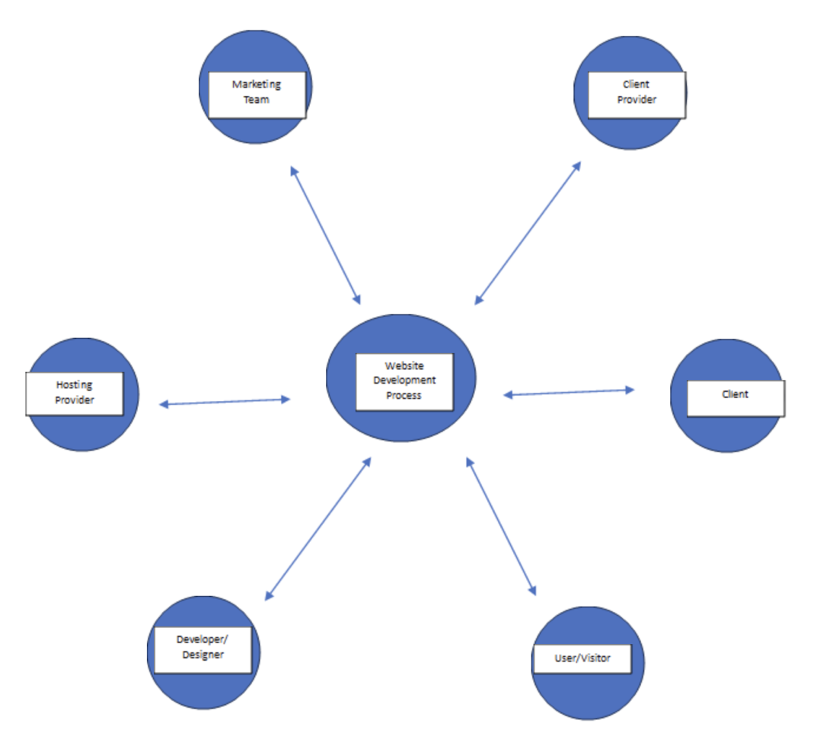

# **Section 2**

# **Executive Summary**

# **Use Case Diagram**

# **Non-Functional Requirements**

# **Context Diagram**

# **Section 3**

# **Executive Summary**

# **Data Flow Diagram Package**

# **Level 0**

# **Level 1 (1 or 2 of them)**

# **Hardware and Software Specifications**

# **Navigation Diagram**

# **Entity-Relationship Diagram**

# **Program Plan (IPO Chart)**

# **Standard Naming Conventions**

# **Section 4**

# **Executive Summary**

# **Training Manual**

# **Challenges**

# **Problems**

# **Discoveries**

# **Test Plans**

# **Challenges**

# **Problems**

# **Discoveries**

# **Technical Manual**

# **Section 5:**

# **Executive Summary**

# **Migration Plan**

# **Explanation of challenges, problems, and discoveries**

# **Personal Project Review**

# **Lessons During Project**

# **Appendix**